SAP TM – Update POD status in outbound delivery

SAP BO : /SCMTMS/TOR

Scenario: Insert POD event in the execution tab in the Freight order and press save – POD status should be updated as Completed in all outbound deliveries.

Create Post action enhancement:

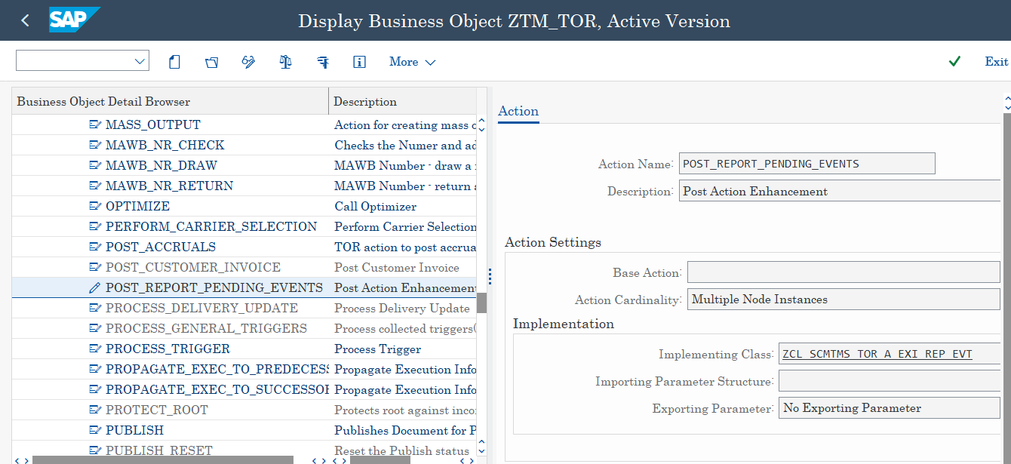

Method : Execute

METHOD /bobf/if_frw_action~execute.  
  
  TYPES:BEGIN OF ty_execution_info,  
          event_code   TYPE /scmtms/tor_event,  
          key          TYPE /bobf/conf_key,  
          execution_id TYPE /scmtms/item_id,  
          status(1)    TYPE c,  
        END OF   ty_execution_info.  
  
  DATA:lv_outbound_del TYPE vbeln_vl,  
       lv_del_item_no  TYPE posnr_vl.  
  
  DATA:ls_vbkok          TYPE vbkok,  
       ls_symsg          TYPE symsg,  
       ls_execution_info TYPE ty_execution_info.  
  
  DATA:lt_vbpok     TYPE vbpok_t,  
       lt_verpo     TYPE tvpodvb_t,  
       lt_prot      TYPE tab_prott,  
       lt_d_exec_tr TYPE /scmtms/t_tor_exec_tr_k.  
  
  DATA:lr_d_exec_tr      TYPE REF TO /scmtms/s_tor_exec_tr_k,  
       lr_param_execinfo TYPE REF TO /scmtms/s_tor_c_execinfo_tr.  
  
*-------------------------------------------------------------------------------------------------  
*Check if POD event reported  
*-------------------------------------------------------------------------------------------------  
  
  CREATE DATA lr_param_execinfo.  
  lr_param_execinfo->do_not_create = abap_true.  
  
  io_read->retrieve_by_association(  
    EXPORTING  
      it_key         = it_key  
      iv_association = /scmtms/if_tor_c=>sc_association-root-executioninformation_tr  
      iv_node        = /scmtms/if_tor_c=>sc_node-root  
      iv_fill_data   = abap_true  
      is_parameters  = lr_param_execinfo  
    IMPORTING  
      et_data        = lt_d_exec_tr ).  
  IF lt_d_exec_tr IS INITIAL.  
    RETURN.  
  ENDIF.  
  
  LOOP AT lt_d_exec_tr REFERENCE INTO lr_d_exec_tr USING KEY to_be_reported WHERE to_be_reported EQ abap_true AND  
                                                                                  event_code     EQ 'POD'.  
    DATA(lv_upd_pod_status) = abap_true.  
    DATA(lv_execution_key)  = lr_d_exec_tr->key.  
    DATA(lv_root_key)       = lr_d_exec_tr->root_key.  
    DATA(lv_event_code)     = lr_d_exec_tr->event_code.  
    DATA(lv_execution_id)   = lr_d_exec_tr->execution_id.  
    EXIT.  
  ENDLOOP.  
  
*-------------------------------------------------------------------------------------------------  
  
*-------------------------------------------------------------------------------------------------  
*Read Root and Item Node data  
*-------------------------------------------------------------------------------------------------  
  IF lv_upd_pod_status EQ abap_true.  
  
    /scmtms/cl_tor_helper_read=>get_tor_data(  
      EXPORTING  
        it_root_key  = it_key  
        io_read      = io_read  
        is_read_req  = VALUE #( et_root      = abap_true  
                                et_all_items = abap_true )  
      IMPORTING  
        et_all_items = DATA(lt_d_items)  
        et_root      = DATA(lt_d_root) ).  
  
*-------------------------------------------------------------------------------------------------  
*Read current Freight order  
*-------------------------------------------------------------------------------------------------  
    IF line_exists( lt_d_root[ key      = it_key[ 1 ]-key  
                               tor_type = 'ZFO1' ] ).  
      DATA(lv_freight_order) = lt_d_root[ key      = it_key[ 1 ]-key  
                                          tor_type = 'ZFO1' ]-tor_id.  
      DATA(lv_key) = lt_d_root[ key      = it_key[ 1 ]-key  
                                tor_type = 'ZFO1' ]-key.  
    ENDIF.  
  
*-------------------------------------------------------------------------------------------------  
*Prepare and Check outbound delivery.  
*-------------------------------------------------------------------------------------------------  
    IF lv_freight_order IS NOT INITIAL.  
      LOOP AT lt_d_items ASSIGNING FIELD-SYMBOL(<lfs_d_items>) WHERE item_type  EQ 'PRD'  AND  
                                                                     trq_cat    EQ '06'   AND  
                                                                     base_btd_id IS NOT INITIAL.  
  
        DATA(lv_base_btd_id) = <lfs_d_items>-base_btd_id.  
        CALL FUNCTION 'CONVERSION_EXIT_ALPHA_OUTPUT'  
          EXPORTING  
            input  = lv_base_btd_id  
          IMPORTING  
            output = lv_base_btd_id.  
  
        CLEAR lv_outbound_del.  
        lv_outbound_del = lv_base_btd_id.  
  
        CALL FUNCTION 'CONVERSION_EXIT_ALPHA_INPUT'  
          EXPORTING  
            input  = lv_outbound_del  
          IMPORTING  
            output = lv_outbound_del.  
  
*Check if the delivery is not yet processed  
        SELECT SINGLE @abap_true  
        FROM likp  
        INTO @DATA(lv_exists)  
        WHERE vbeln EQ @lv_outbound_del AND  
              pdstk EQ 'A'.  
        IF sy-subrc EQ 0.  
  
          CLEAR ls_vbkok.  
          ls_vbkok = VALUE #( podat =  sy-datum  
                              potim =  sy-uzeit  
                              kzpod =  'B' ).  
  
          CLEAR:lv_del_item_no,lt_vbpok,lt_verpo.  
          lv_del_item_no = <lfs_d_items>-base_btditem_id.  
          lt_vbpok = VALUE #( ( vbeln_vl = lv_outbound_del  
                                posnr_vl = lv_del_item_no  
                                kzpod    = 'X') ).  
  
          CALL FUNCTION 'WS_DELIVERY_UPDATE'  
            EXPORTING  
              vbkok_wa                 = ls_vbkok  
              delivery                 = lv_outbound_del  
              if_error_messages_send_0 = space  
              commit                   = abap_false  
              if_database_update       = '2'  
            TABLES  
              tvpod_tab                = lt_verpo  
              vbpok_tab                = lt_vbpok  
              prot                     = lt_prot.  
  
          IF line_exists( lt_prot[ msgty = 'E' ] ).  
  
            /scmtms/cl_msg_helper=>msg_helper_add_symsg(  
              EXPORTING  
                iv_bo_key    = /scmtms/if_tor_c=>sc_bo_key  
                iv_node_key  = /scmtms/if_tor_c=>sc_node-root  
                iv_key       = lv_root_key  
                iv_probclass = /scmtms/cl_applog_helper=>sc_al_probclass_important  
              CHANGING  
                co_message   = eo_message ).  
  
            et_failed_key = VALUE #( ( key = lv_root_key ) ).  
  
            LOOP AT lt_prot ASSIGNING FIELD-SYMBOL(<lfs_prot>) WHERE msgty = 'E'.  
  
              CLEAR ls_symsg.  
              ls_symsg = VALUE #( msgty = <lfs_prot>-msgty  
                                  msgid = <lfs_prot>-msgid  
                                  msgno = <lfs_prot>-msgno  
                                  msgv1 = <lfs_prot>-msgv1  
                                  msgv2 = <lfs_prot>-msgv2  
                                  msgv3 = <lfs_prot>-msgv3  
                                  msgv4 = <lfs_prot>-msgv4 ).  
  
              IF eo_message IS BOUND.  
                eo_message->add_message(  
                  is_msg  = ls_symsg  
                  iv_node = /scmtms/if_tor_c=>sc_node-root  
                  iv_key  = lv_root_key ).  
              ENDIF.  
            ENDLOOP.  
  
*Pass data to buffer to skip the POD event save  
            ls_execution_info = VALUE #( event_code   = lv_event_code  
                                         key          = lv_execution_key  
                                         execution_id = lv_execution_id  
                                         status       = 'E' ).  
  
            EXPORT ls_execution_info FROM ls_execution_info TO MEMORY ID 'ZPOD_EVT'.  
  
            RETURN.  
          ELSE.  
            CALL FUNCTION 'DEQUEUE_EVVBLKE'  
              EXPORTING  
                mode_likp = 'E'  
                mandt     = sy-mandt  
                vbeln     = lv_outbound_del.  
          ENDIF.  
        ENDIF.  
      ENDLOOP.  
  
*Dequeue Sales Order  
      SELECT SINGLE vgbel  
      FROM lips  
      INTO @DATA(lv_sales_order)  
      WHERE vbeln EQ @lv_outbound_del.  
      IF sy-subrc EQ 0.  
        CALL FUNCTION 'DEQUEUE_EVVBAKE'  
          EXPORTING  
            mode_vbak = 'E'  
            mandt     = sy-mandt  
            vbeln     = lv_sales_order.  
      ENDIF.  
  
*-------------------------------------------------------------------------------------------------  
*Prepare and Update outbound delivery POD status as Confirmed.  
*-------------------------------------------------------------------------------------------------  
      LOOP AT lt_d_items ASSIGNING <lfs_d_items> WHERE item_type   EQ 'PRD'  AND  
                                                       trq_cat     EQ '06'   AND  
                                                       base_btd_id IS NOT INITIAL.  
  
        CLEAR lv_base_btd_id.  
        lv_base_btd_id = <lfs_d_items>-base_btd_id.  
        CALL FUNCTION 'CONVERSION_EXIT_ALPHA_OUTPUT'  
          EXPORTING  
            input  = lv_base_btd_id  
          IMPORTING  
            output = lv_base_btd_id.  
  
        CLEAR lv_outbound_del.  
        lv_outbound_del = lv_base_btd_id.  
  
        CALL FUNCTION 'CONVERSION_EXIT_ALPHA_INPUT'  
          EXPORTING  
            input  = lv_outbound_del  
          IMPORTING  
            output = lv_outbound_del.  
  
*Check if the delivery is not yet processed  
        CLEAR lv_exists.  
        SELECT SINGLE @abap_true  
        FROM likp  
        INTO @lv_exists  
        WHERE vbeln EQ @lv_outbound_del AND  
              pdstk EQ 'A'.  
        IF sy-subrc EQ 0.  
  
          CLEAR ls_vbkok.  
          ls_vbkok = VALUE #( podat =  sy-datum  
                              potim =  sy-uzeit  
                              kzpod =  'B' ).  
  
          CLEAR:lv_del_item_no,lt_vbpok,lt_verpo.  
          lv_del_item_no = <lfs_d_items>-base_btditem_id.  
          lt_vbpok = VALUE #( ( vbeln_vl = lv_outbound_del  
                                posnr_vl = lv_del_item_no  
                                kzpod    = 'X') ).  
  
          CALL FUNCTION 'ZTM_OUTBOUND_DELIVERY_UPDATE' IN UPDATE TASK  
            EXPORTING  
              is_vbkok     = ls_vbkok  
              iv_delivery  = lv_outbound_del  
              iv_vbeln     = lv_sales_order  
            TABLES  
              it_vbpok_tab = lt_vbpok  
              it_vpod_tab  = lt_verpo.  
  
          CALL FUNCTION 'DEQUEUE_EVVBAKE'  
            EXPORTING  
              mode_vbak = 'E'  
              mandt     = sy-mandt  
              vbeln     = lv_sales_order.  
  
        ENDIF.  
      ENDLOOP.  
  
*-------------------------------------------------------------------------------------------------  
  
    ENDIF.  
  ENDIF.  
  
ENDMETHOD.

FUNCTION ztm_outbound_delivery_update.  
*"----------------------------------------------------------------------  
*"*"Update Function Module:  
*"  
*"*"Local Interface:  
*"  IMPORTING  
*"     VALUE(IS_VBKOK) LIKE  VBKOK STRUCTURE  VBKOK  
*"     VALUE(IV_DELIVERY) LIKE  LIKP-VBELN  
*"     VALUE(IV_VBELN) TYPE  VBELN_VA  
*"  TABLES  
*"      IT_VBPOK_TAB STRUCTURE  VBPOK OPTIONAL  
*"      IT_VPOD_TAB STRUCTURE  TVPODVB OPTIONAL  
*"----------------------------------------------------------------------  
  
  CALL FUNCTION 'DEQUEUE_EVVBAKE'  
    EXPORTING  
      mode_vbak = 'E'  
      mandt     = sy-mandt  
      vbeln     = iv_vbeln.  
  
  CALL FUNCTION 'WS_DELIVERY_UPDATE'  
    EXPORTING  
      vbkok_wa  = is_vbkok  
      delivery  = iv_delivery  
    TABLES  
      tvpod_tab = it_vpod_tab  
      vbpok_tab = it_vbpok_tab.  
  
ENDFUNCTION.

In order to cancel the save of POD event , enhance determination class and create POST exit on the execute method:

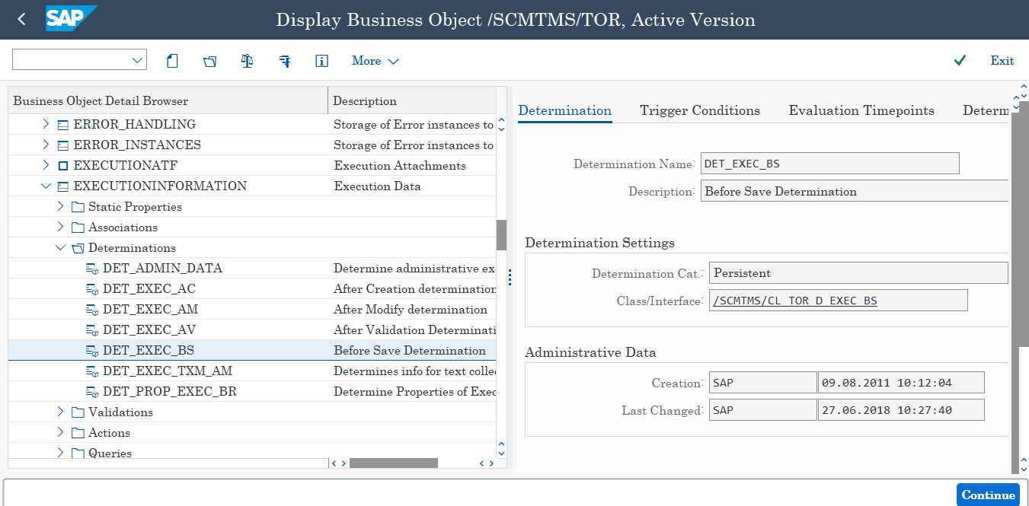

METHOD ipo_ztm_ei_pod_exec_bs~execute.  
*"------------------------------------------------------------------------*  
*" Declaration of POST-method, do not insert any comments here please!  
*"  
*"methods EXECUTE  
*"  importing  
*"    !IS_CTX type /BOBF/S_FRW_CTX_DET  
*"    !IT_KEY type /BOBF/T_FRW_KEY  
*"    !IO_READ type ref to /BOBF/IF_FRW_READ  
*"    !IO_MODIFY type ref to /BOBF/IF_FRW_MODIFY  
*"  changing  
*"    !EO_MESSAGE type ref to /BOBF/IF_FRW_MESSAGE  
*"    !ET_FAILED_KEY type /BOBF/T_FRW_KEY  
*"  raising  
*"    /BOBF/CX_FRW .  
*"------------------------------------------------------------------------*  
  
    TYPES:BEGIN OF ty_execution_info,  
            event_code   TYPE /scmtms/tor_event,  
            key          TYPE /bobf/conf_key,  
            execution_id TYPE /scmtms/item_id,  
            status(1)    TYPE c,  
          END OF   ty_execution_info.  
  
    DATA:ls_execution_info TYPE ty_execution_info.  
  
    IMPORT ls_execution_info TO ls_execution_info FROM MEMORY ID 'ZPOD_EVT'.  
    IF ls_execution_info IS NOT INITIAL.  
      FREE MEMORY ID 'ZPOD_EVT'.  
  
      IF ls_execution_info-event_code EQ 'POD' AND  
         ls_execution_info-status     EQ 'E'.  
        et_failed_key = VALUE #( ( key = ls_execution_info-key ) ).  
      ENDIF.  
    ENDIF.  
  
  ENDMETHOD.  
ENDCLASS.

Unit Test Results:

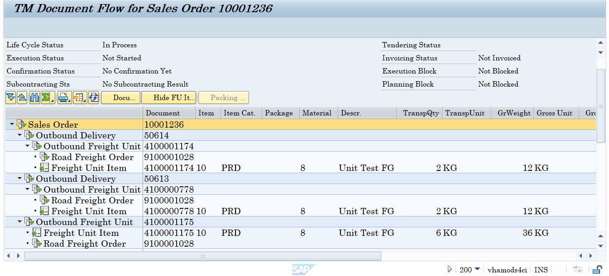

Before POD event report

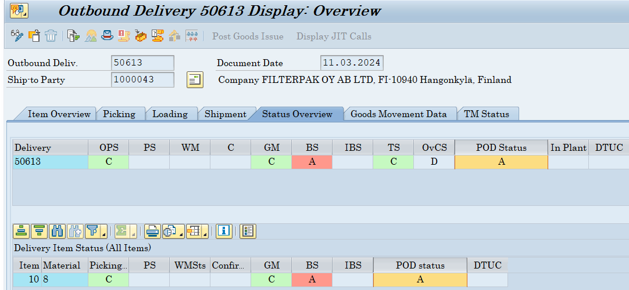

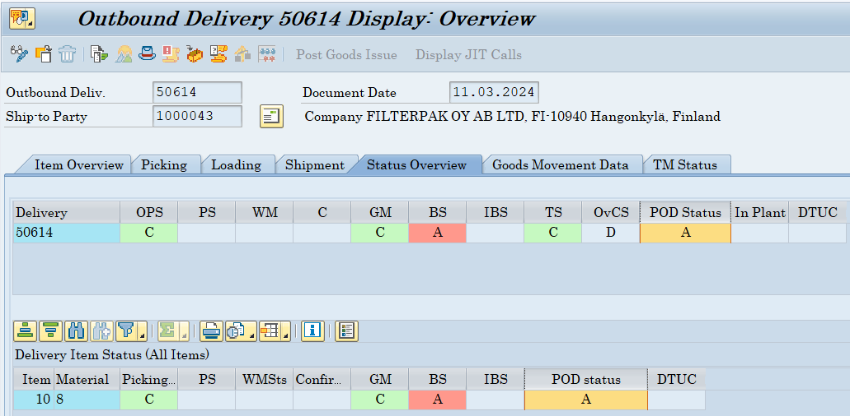

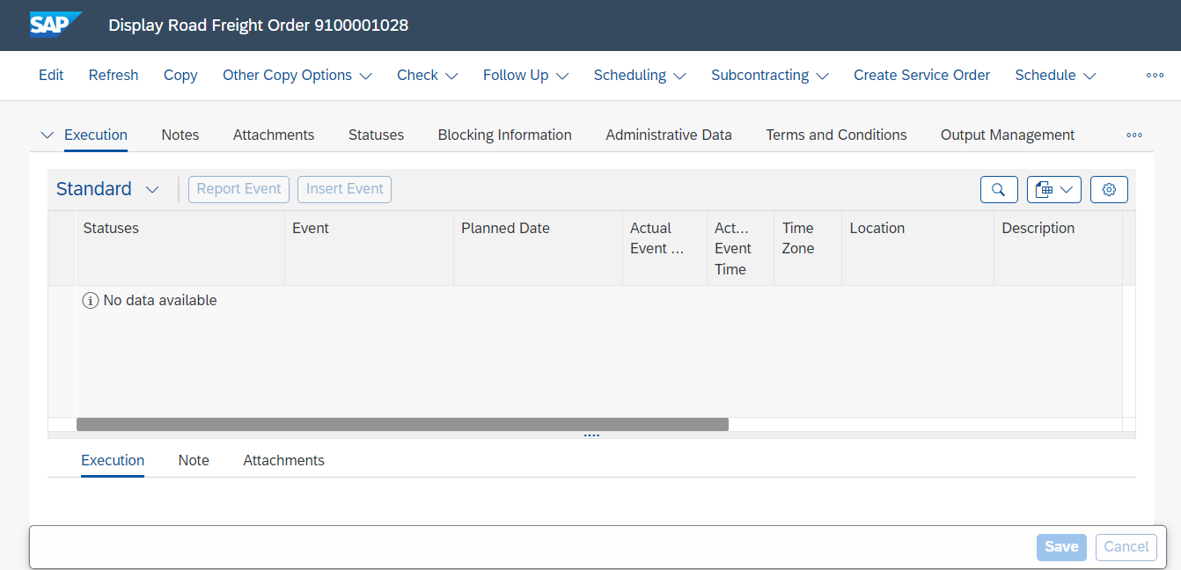

After POD event reported in the Freight order 9100001028

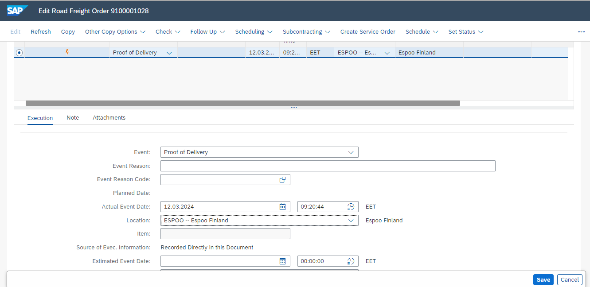

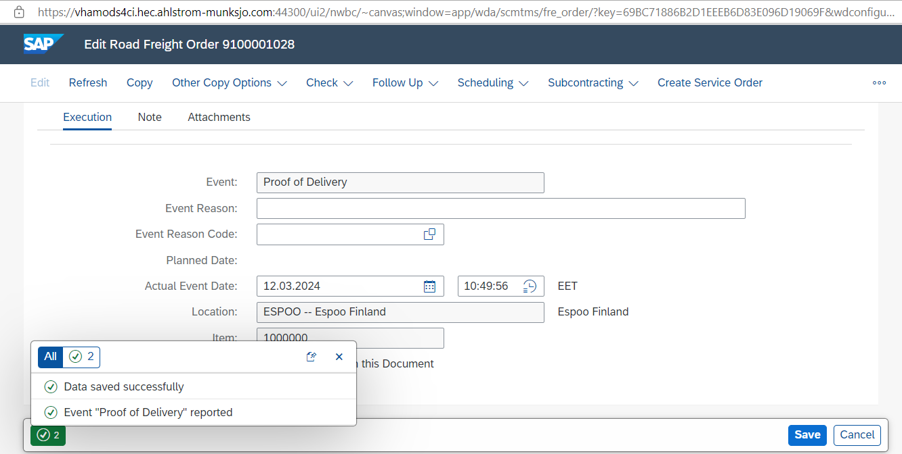

POD status updated as Confirmed in both outbound deliveries

